

**Summer Holiday Homework 2025-26**

**Class-VII**

**Subject- English**

1. Read a English newspaper/magazine of your choice and select any two unseen passage then from 5 questions from each passage and write their answer.

2. Write a paragraph on the skill you have learnt during vacation period.you may add picture.

3. Word formation:-Make new words from the words GRAND FATHER &FRIENDSHIP.

4. Write Homophones and Homonyms of 10 words.

5. Draw a short comic strip on a funny story.

6 . Make a colourful chart of Adjective and its kinds with example.

**विषय-हिंदी**

1-निम्नलिखित विषयों पर सचित्र अनुच्छेद लिखिए-

( i) पानी बचाओ (ⅱ) अनुशासन (ⅲ) बागवानी (V) नानी का घर

2- "अपने ग्रीष्मकालीन अवकाश का अनुभव अपने शब्दों में लिखें।

3. किन्ही 10 मुहावरों का अर्थ लिखकर वाक्य प्रयोग करें (Book page No - 196 )

4- रहीम दास जी का सुंदर चित्र बनाकर उनके चार दोहे लिखकर एक चार्ट पेपर तैयार कीजिए ।

**Subject- Sanskrit**

प्र० 1- 1 से 20 तक संस्कृत संख्या याद करके अपनी कॉपी में लिखिए। [पृष्ठ संख्या 93]

प्र० 2- ‘पा-पिव् धातु के रूप अथवा रक्ष धातु के रूप लृट और लकार में लिखिए।

प्र० 3 - 21 से 30 तक पर्यायवाची शब्द याद करके लिखिए। (Book page no)

प्र० 4 – अग्रजः से कटुः तक विलोम शब्द याद करके लिखिए |

**Subject- Mathematic**

Q.1 Write tables 2 to 25.

Q.2 Do model Question Paper 1 On page no.75.

Q.3 Do logical reasoning and Aptitude based Question on book Page no-292, 293, 294, 295 (do it in maths book)

Q.4 Make a below-model of any one topic given below

(i) Geometrical (ii) Graphical (Data Handling) (iii) Pythagoras theorem.

**Subject- Science**

\***Model or Poster (Creative work)**

**Q-1. Make any one of the following"**

A- Make a Poster or chart showing the uses of acids, bases, and salts in daily life, Decorate it with pictures effectively-

B- Draw then Model of Human digestive system or Amoeba.

**Q-2. Research and write (Awareness Activity)**

A- Name two natural and two synthetic indicators.

B- What happens when an acid reacts with a base ?

C- Name two acid s and bases commonly found at home.

**Q-3. Practice Questions-**

Prepare answers to the following -

A - Define the following terms-

a) conduction b) Radiation, c)Indicator

B- What is the difference between heat and temperature?

C- Write the difference between natural and synthetic indicators.

**Subject-S.S. T**

1.Write States and their Capitals and Union territories of India.

2. Write the important things about our State (U.P) – decorated (files)

(i) Populations- (ii) Area (iii) Capital- (iv) Language-

(v) Rivers

(vi) State flower, state animal, state symbol, State sweet, State tree,

(vii) first Governor of U.P...

(viii) first CM. of U.P.

(ix) NCR Districts of UP

(x) first women CM. in U.P.

(xi) Total Seats of Lok Sabha in U.P

(xii) Total Seats of Rajya Sabha in U.P.

(xiii) Total Seats of legislative assembly in UP.

(xiv) Total Seats of legislative Council in UP.

(xv) Total divisions in UP.

(xvi) Total districts in UP.

3. Fill the Map book Page no. - 53, 55, 57 59,61

**Computer**

1. Convert the following decimal number to their equivalent binary form.

(i) 1008 (ii) 572 (iii) 256 (iv) 200

2. Convert the following binary numbers to their equivalent chemical form.

(i) 1111 (ii) 11101011 (iii) 1010001 (V) 11101011

3. Explain the classification of Computer Software.

4. Explain the services offered by Internet. (Page No.149)

5. Draw the diagram! Computer parts in your notebook.

**Subject- General Knowledge**

1- Write something about five historical places in India and paste there picture on A-4 Sheet.

2- Write 10 ways how we can save the water.

3. Who is the present chief minister of uttar Pradesh ? write something about his achievements.

4. When do we celebrate children’s day why we celebrate it?

5- Write something about yourself

6- Answer the following questions

(i) Which is the largest organ of the human body?

(ii) Which part of the human body plums blood of the whole body ?

(iii) What is also known as the voice box ?

(iv) How many bones does the adult human body have

(v) What substance are the nails made of ?

(vi) What do we call our shoulder joint ?

(vii) The part which occupies 80% of the brain.

**Subject- Drawing**

1- Draw given calligraphy on A-4 sheet and decorate it with colours.

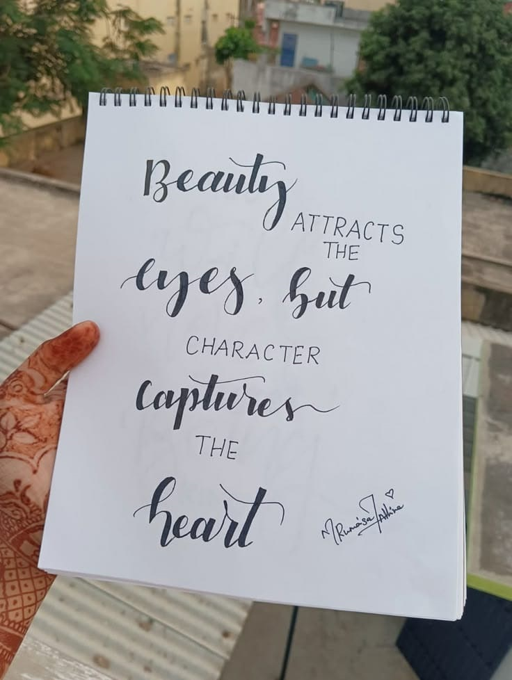

**Creativity corner :-**

**Prepare a Father’s day card, give it to your father and take a short video or pictures.**

1- Father' day Celebration on 15 June 2025

**Prepare a short video or take pictures related to any one activity**

1- Environmental day Celebration on 5 June 2025.

2- Use any recyclable material like - plastic , bottle, cardboard boxes, old C.D and make any craft material

3- Reuse rain water.

4- Plant any indoor or outdoor plant in your house.

5- Any ecofriendly activity to save mother earth.

6- Implant Any seed in soil and observe its growth.

**Perform any one activity and prepare a short video or take some pictures.**

1- International Yoga day Celebration on21 June 2025- 2- Surya namaskar

3- Tadasana (Mountain Pose) 4- Vrksasana (Tree pose)

5- Bhujangasana (Cobra Pose) 6- Paschimottanasana (seated Forward bend)

**Note – (i) Revise the syllabus covered so far in every subject.**

**(ii) Use your subject notebook to solve question.**

**iii) 5 marks will be awarded in each subject in Periodic test-II for completing the holiday homework.**